* Table of Contents/Index with page numbering
* Introduction:

Electricity is the ultimate need for almost every citizen of our country. With the advent of new technology we are more dependent on electricity now. Currently the electric supply offices use paper books and ledgers to track & manage customer applications, complaints. As a result, it takes longer time and extra effort to serve customers with existing inefficient system. Electric Supply Customer Management System (will be referred as **ESCMS** in this document) is a computerized solution for managing customer needs in Electric Supply offices. Electric Supply Customer Management System will enable electric supply offices to maintain computerized records and manage customer needs more efficiently with help of sophisticated customer management techniques and technologies.

* Objectives

The main objective of this project is to automate the process in an Electric Supply office. Electric Supply Customer Management System will be used by Electric Supply Employees to enter various data about the Customers and their needs. The Employees will update the status of customer requests; track the progress of the work & transactions made in Electric Supply Customer Management System. It can generate reports and receipts required to serve customer request and queries. In a nutshell **ESCMS** will be the backbone of an Electric Supply office and it will be a next generation solution for better customer service and customer satisfaction.

* System Analysis
* Identification of Need
* Preliminary Investigation
* Feasibility Study
* Project Planning & Scheduling:

### Gantt chart

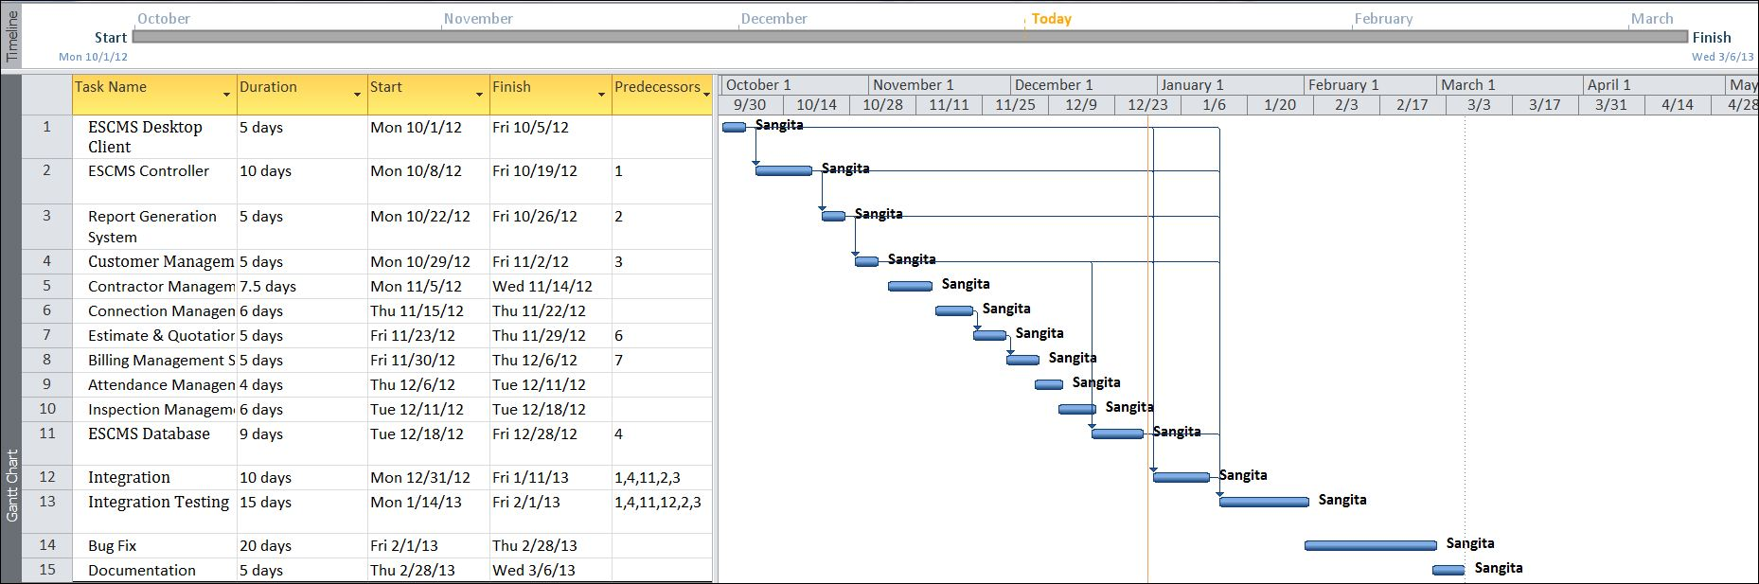

### Tracking Gantt

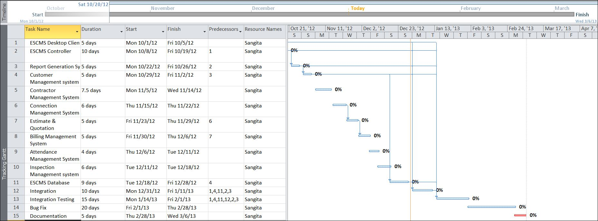

### Pert chart (Network Diagram)

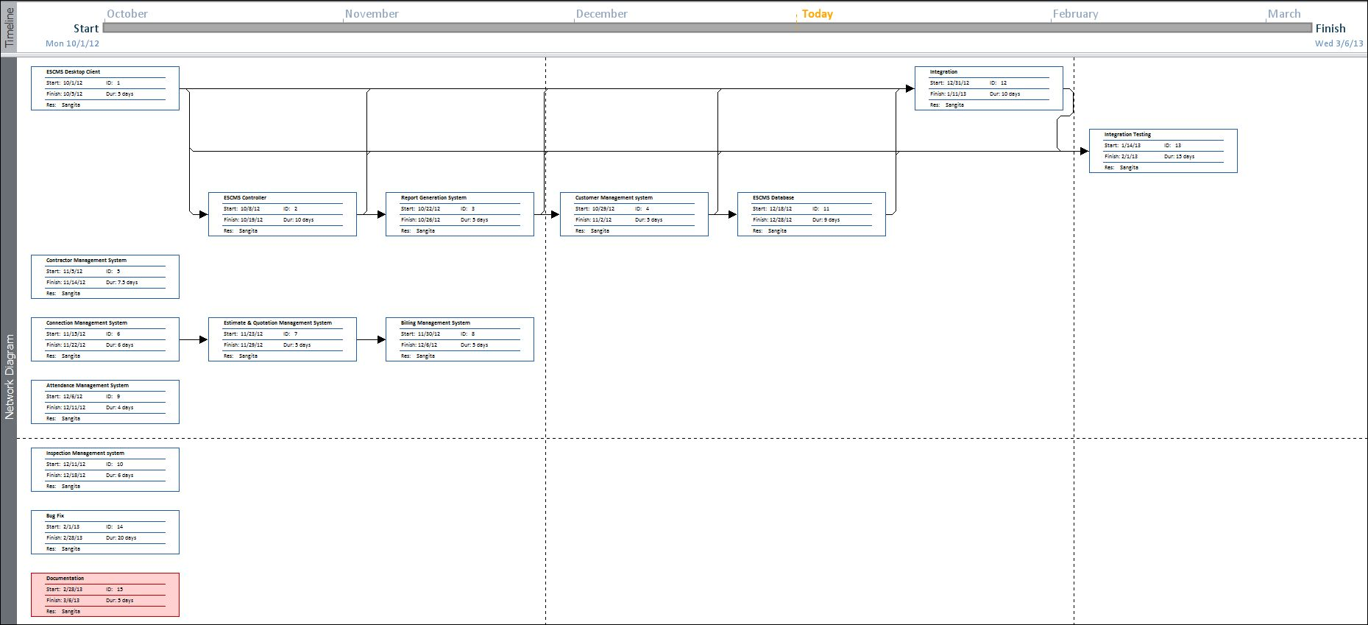

* Software requirement specifications (SRS)
* Software Engineering Paradigm applied
* Data models (like DFD), Control Flow diagrams, State Diagrams/Sequence diagrams, Entity Relationship Model, Class Diagrams/CRC Models/Collaboration Diagrams/Use-case Diagrams/Activity Diagrams depending upon your project requirements
* System Design
* Modularisation details
* Data integrity and constraints
* Database design, Procedural Design/Object Oriented Design
* User Interface Design
* Test Cases (Unit Test Cases and System Test Cases)
* Coding
* Complete Project Coding
* Comments and Description of Coding segments
* Standardization of the coding

12

* Code Efficiency
* Error handling
* Parameters calling/passing
* Validation checks
* Testing
* Testing techniques and Testing strategies used
* Testing Plan used
* Test reports for Unit Test Cases and System Test Cases
* Debugging and Code improvement
* System Security measures (Implementation of security for the project developed)
* Database/data security
* Creation of User profiles and access rights
* Cost Estimation of the Project along with Cost Estimation Model
* Reports (sample layouts should be placed)
* Future scope and further enhancement of the Project
* Bibliography
* Appendices (if any)
* Glossary.